Disability Facts and Cycle

1. People with disabilities make up 15% of the population in Tennessee, but that requires people to disclose their disability, which not everyone is comfortable doing, so this number is likely higher.
Consideration: Per the Centers for Disease Control & Prevention (May 2022) close to 1 in 3 (29%) of Tennesseans experience some form of disability. This equates to almost 1.6 million Tennesseans (1,552,858.)
2. People with disabilities made up 5% of children under 18, 13% of people 18-64, and 38% of seniors in Tennessee.
3. Among people aged 25 and older in Tennessee, people with disabilities were less likely to have graduated from high school (78%) than people without disabilities (91%) and were less likely (20%) to have completed post-secondary education than people without disabilities (41%).
Consideration: Definition of “diploma.” Academic, alternative, and special education (the 3 types of diplomas). The latter does not count in the school’s overall graduation rate.
4. 33% of people with disabilities are employed.
Consideration: Likely higher due to COVID, and/or restrictions on mitigation measures. a disability Cycle came from an advocate, and her social media account is Pacing Pixie.
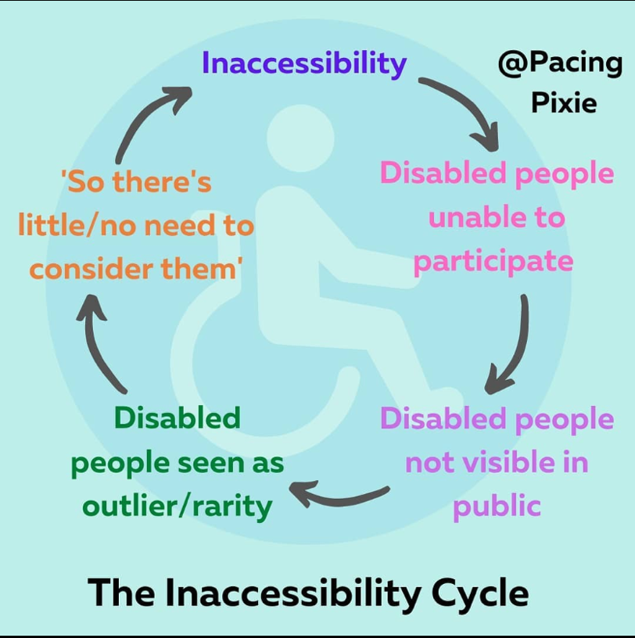
ID: a circular cycle around the wheelchair disability symbol.
the cycle is labeled “The Inaccessibility Cycle”
the steps are inaccessibility ➡️
disabled people unable to participate ➡️
disabled people not visible in public ➡️
disabled people seen as outlier/rarity ➡️
‘so there’s little/no need to consider them’ ➡️
and the final arrow leads back to inaccessibility, creating an endless loop

